Usage Statistics for snydersstoughton.com
Summary Period: Last 12 Months
Generated 16-Feb-2009 00:58 EST

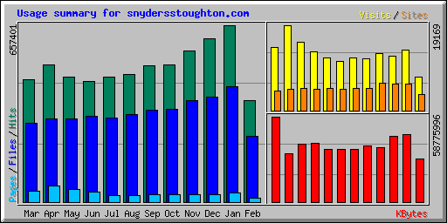
Summary by Month
Month | Daily Avg |  |  |  | Monthly Totals
Month | Hits | Files | Pages | Visits | Sites | KBytes | Visits | Pages | Files | Hits
Feb 2009 | 23557 | 15273 | 987 | 468 | 3715 | 29605050 | 7495 | 15794 | 244379 | 376923
Jan 2009 | 21206 | 13882 | 1070 | 438 | 6016 | 46379717 | 13597 | 33188 | 430348 | 657401
Dec 2008 | 19576 | 12551 | 841 | 395 | 5914 | 45176554 | 12263 | 26088 | 389097 | 606880
Nov 2008 | 18680 | 12594 | 963 | 428 | 6160 | 37718591 | 12857 | 28906 | 377841 | 560426
Oct 2008 | 16491 | 11145 | 850 | 378 | 4913 | 38572479 | 11723 | 26365 | 345521 | 511234
Sep 2008 | 16940 | 11408 | 913 | 396 | 4927 | 36295908 | 11898 | 27419 | 342256 | 508218
Aug 2008 | 15324 | 10543 | 759 | 356 | 4874 | 36485561 | 11057 | 23551 | 326833 | 475048
Jul 2008 | 14976 | 10118 | 825 | 379 | 4961 | 36561538 | 11759 | 25592 | 313679 | 464268
Jun 2008 | 15001 | 10662 | 1247 | 438 | 4879 | 40571509 | 13164 | 37433 | 319874 | 450039
May 2008 | 15009 | 9954 | 1472 | 495 | 4994 | 39656455 | 15372 | 45648 | 308596 | 465293
Apr 2008 | 17032 | 10289 | 2027 | 638 | 4831 | 33410770 | 19169 | 60831 | 308677 | 510982
Mar 2008 | 14718 | 9412 | 1275 | 460 | 4358 | 58775996 | 14278 | 39543 | 291786 | 456284
Totals |  |  |  |  |  | 479210128 | 154632 | 390358 | 3998887 | 6042996

Generated by Webalizer Version 2.01

